**CHAPTER 3**

**MULTIMEDIA AND WEB DEVELOPMENT**

**3.1. Introduction**

**Multimedia** is defined in many ways. Most of the definitions agree on the characteristic that multimedia contains texts, graphics, animations, video and sound in a unified way and the content can be structured and presented differently.

**Web development** is a broad term for the work involved in developing a web site for the Internet (World Wide Web) or an intranet (a private network). Among web professionals, "web development" usually refers to the main non-design aspects of building web sites: writing mark-up and coding.

**3.2. World Wide Web**

WWW stands for World Wide Web**.** A technical definition of the World Wide Web is: all the resources and users on the Internet that are using the Hypertext Transfer Protocol (HTTP).

A broader definition comes from the organization that Web inventor Tim Berners-Lee helped found, the World Wide Web Consortium (W3C).

The World Wide Web is the universe of network-accessible information, an embodiment of human knowledge.

In simple terms, The World Wide Web is a way of exchanging information between computers on the Internet, tying them together into a vast collection of interactive multimedia resources.

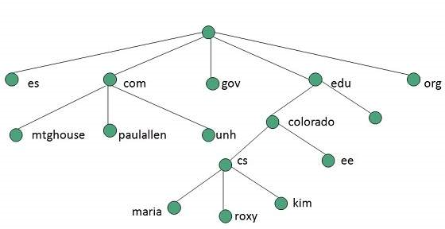

Fig: 3.1. Tree Structure For WWW

**3.2.1. WWW Architecture**

There has been huge growth in field of web which may lead to overload the internet and degrade its performance. Hence more better protocol is required to be developed.

WWW architecture is divided into several layers as shown in the following diagram Fig 3.3

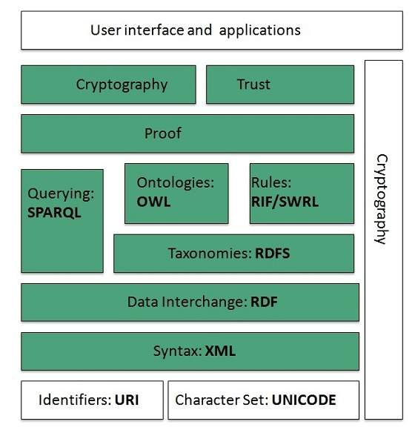

Fig:3.3 Architecture of WWW

**3.2.2. WWW Operation**

WWW works on client- server approach. Following steps explains how the web works:

1. User enters the URL (say, http://www.tutorialspoint.com) of the web page in the address bar of web browser.
2. Then browser requests the Domain Name Server for the IP address corresponding to www.tutorialspoint.com.
3. After receiving IP address, browser sends the request for web page to the web server using HTTP protocol which specifies the way the browser and web server communicates.
4. Then web server receives request using HTTP protocol and checks its search for the requested web page. If found it returns it back to the web browser and close the HTTP connection.
5. Now the web browser receives the web page, it interprets it and display the contents of web page in web browser’s window.

The following diagram Fig: 3.4 shows how World Wide Web(WWW) is been operated

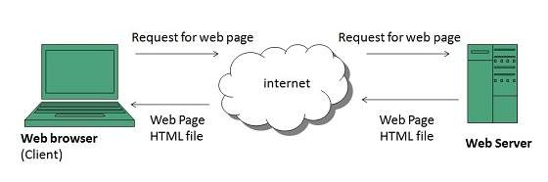

Fig 3.4 WWW Operation

**3.3. Elements of Multimedia**

The different building blocks of Multimedia are Text, Images and graphics, Audio, Video, and Animation. Any multimedia application consists any or all of them.

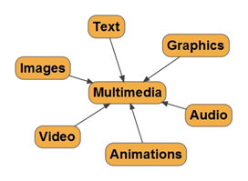

Fig:4.2 Elements of Multimedia

1. Text  
 Text is the basis for word processing programs and is still the fundamental information used in many multimedia programs.

2. Static Graphics images  
 Static graphics images are an important part of multimedia because humans are visually oriented. As the old Chinese proverb goes, “A picture is worth a thousand words. “Windows is also a visual environment. This makes displaying graphics images easier than it would be in a DOS-based environment.

3. Audio Sound  
 The integration of audio sound into a multimedia application can provide the user with information not possible through any other method of communication. Some types of information can't be conveyed effectively without using sound.

4. Animation   
 Animation refers to moving graphics images. The movement of somebody giving CPR makes it much easier to learn cardiopulmonary resuscitation, rather than just viewing a static picture. Just as a static graphics image is a powerful form of communication, such is the case with animation. Animation is especially useful for illustrating concepts that involve movement.

5. Full-Motion Video   
 Full-motion video, such as the images portrayed in a television, can add even more to a multimedia application. Although full-motion video may sound like an ideal way to add a powerful message to a multimedia application.

**3.4 ADDIE Model of Multimedia**

The instructional development model ADDIE is also appropriate for planning and developing multimedia resources.

 ADDIE – This acronym stands for the 5 phases, they are:

* **Analyze**- analyze learn characteristics, task to be learned, etc.
* **Design**- develop learning objectives, choose an instructional approach.
* **Develop**- create instructional or training materials.
* **Implement**- deliver or distribute the instructional materials.
* **Evaluate**- make sure the materials achieved the desired goals.

**3.5 Advantage and Disadvantage of Multimedia**

**Advantage of Multimedia**

* Increase sales, market share and profit.
* Lower per unit cost.
* Expand life cycle of the product

**Disadvantage of Multimedia**

* Extra cost
* Financial risk
* Product adaptation
* Lack of market information